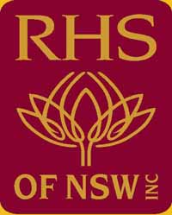
THE ROYAL HORTICULTURAL SOCIETY OF N.S.W. INC

MEMBERSHIP – AFFILIATED SOCIETIES

1st July, 2018 – 30th June, 2019

If your Society was an affiliated member of this Society prior to December 2017 your membership
will expire on 30th June. 2018. If your Society joined after March 2018, you are financial until 30th June, 2019.

You can confirm your Society’s financial status with the Hon. Treasurer, Mrs. Jacqueline Tweedie by email jackietweedie@hotmail.com or by phone on (02) 9872 1862.

MEMBERSHIP RENEWAL DETAILS $42 AFFILIATED SOCIETIES

SOCIETY’S NAME …………………………………………………..…………………………….

NAME OF PRESIDENT ……………………………………………..……………………………

NAME OF SECRETARY …………….………………………………….………………..……...

POSTAL ADDRESS ………………….…………………………………….………….….………

…………………………………………..…………. POST CODE …………….….…..………

SOCIETY CONTACT PHONE NUMBER ……………………………………………....……..

EMAIL ADDRESS ………………………………………………….…… (Contact details only)

NUMBER OF MEMBERS …………………………..

Your payment can be made using cheque/money orders made payable to:

The RHS of NSW Inc.

Post your payment to:

P.O. BOX 6070
BAULKHAM HILLS BC NSW 2153

RECEIPT NUMBER ……………..…….. (Office use only) Date of receipt …………….……….

